|  |  |
| --- | --- |
| Thanksgiving Dinner Example | [top](http://www.umich.edu/~scps/html/09chap/html/prof.htm#top) |

Our extended familt consists of 25 people who will be attending our celebration. Let's consider our dinner menu:

|  |  |  |
| --- | --- | --- |
|  |  | Time Requirements |
| **Main Course:** | Roasted turkey (of course) with dressing (studding) | clean (1/2 hr), stuff (1/2 hr), cook (7 hrs at 350°F), cool and slice (1 hr) |
| **Vegetable:** | Green beans with mushroom sauce | prep. time (30 min), microwave (30 min) |
| **Patato:** | Sweet potato casserole | prep. time (30 min), cook (2 hrs at 350°F) |
| **Sauce:** | Jelly cranberry sauce | open can, slice, serve |
| **Dessert:** | Pumpkin Pie | prep. time (3/4 hr), cook (1 hr at 425°F |
| **Beverages:** | Coffee, Tea, Milk, Water, White wine | prep. time (minimal) |
|  |  |  |
|  |  |  |
|  |  |  |

Clearly, the successful preparation and serving of the Thanksgiving meal will require substantial planning and coordination by the cook. A Gantt Chart will help us organize our time and resources (stove, microwave, etc.). We'd like to sit down to eat at 4 PM. The longest "lead-time" item is the turkey, which requires 9 hours to prepare. Thus, using the turkey as a yardstick, we must begin our preparations by at least 7 AM (a long day for the cook!). Let's try to fit this into a Gantt Chart for the preparation of the entire meal.

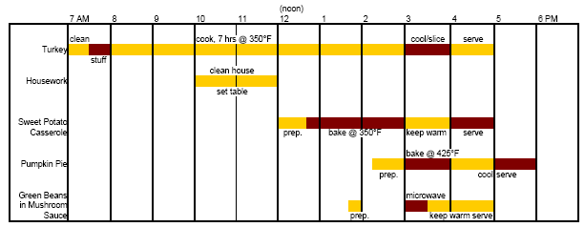

The Gantt Chart shows the hectic nature of the Thanksgiving dinner preparations clearly. Any time conflicts should be apparent from the chart.

**Critical Path for Thanksgiving dinner**

Another example of the use of critical path management is for the preparation of the annual Thanksgiving diner. For the meal to be served on time (and to keep the guests happy) there are several critical steps in the preparation that must be completed in a timely manner or substantial delays will result. In the figure below. for example. the bold lines and boxes indicate the critical path. It refers to items that require a fair amount of time lo complete. If the schedule "slips," the meal will be delayed. For example, the turkey requires approximately eight hours to clean, stuff, and cook. If the preparation of the turkey is delayed, chances are the serving time will be delayed too. The sweet potato casserole also requires a long time to complete (more than 3.5 hours), so it is critical that it is completed on schedule, or the meal will be delayed. Noncritical path items, such as setting the table, cleaning the house, and preparing the pie for baking, can be done as time permits after the critical items are completed.

